**Modern JavaScript**

A block scope is the area within if, switch conditions or for and while loops. Whenever you see {curly brackets}, it is a block. In ES6, const and let keywords allow developers to declare variables in the block scope, which means those variables exist only within the corresponding block.

**{**

// Block Scope

**}**

**if** **(true)** **{**

// Block Scope

**}**

**for** **(var** i **=** 1**;** i **<=** 10**;** i**++)** **{**

// Block Scope

**}**

**function** sum**(**a**,** b**)** **{**

// Function Scope

**var** result **=** a **+** b**;**

**}**

sum**(**4 **+** 3**);**

**Const**

// Scalar values behaves as immutable objects

**const** answer **=** 42**;**

**const** greeting **=** 'Hello'**;**

// Arrays and Objects, const guarantees whe are working with the same reference, but the conten of the reference can be mutated

**const** numbers **=** **[**2**,** 4**,** 6**];**

**const** person **=** **{**

firstName**:** 'John'**,**

lastName**:** 'Doe'**,**

**};**

//person = 0; // error

person**.**firstName **=** 'Pedro'**;** // works

**Arrow vs regular functions**

**const** X **=** **function()** **{**

// "this" here is the caller of X

**};**

**const** Y **=** **()** **=>** **{**

// "this" here is NOT the caller of Y

// It's the same "this" found in Y's scope

**};**

Regular functions give access to their "calling" environment while arrow functions give access to their "defining" environment. The value of the "this" keyword inside a regular function depends on HOW the function was CALLED (the OBJECT that made the call).

The value of the "this" keyword inside an arrow function depends on WHERE the function was DEFINED (the SCOPE that defined the function).

console**.**log**(this);**

**const** testerObj **=** **{**

func1**:** **function()** **{**

console**.**log**(**'In func1'**,** **this);**

**},**

func2**:** **()** **=>** **{**

**var** thisLocal **=** **this;**

console**.**log**(**'In func2'**,** **this);**

console**.**log**(**thisLocal**);**

**}**

**};**

testerObj**.**func1**();** // this is associated with the caller (testerObj)

testerObj**.**func2**();** // this is associated with the same scope where the function is defined (PLAYGROUND)

// const square1 = (a) => {

// return a * a;

// };

// const square2 = (a) => a * a;

// const square3 = a => a * a;

display**.**log**([**1**,** 2**,** 3**,** 4**].**map**(**a **=>** a **\*** a**));**

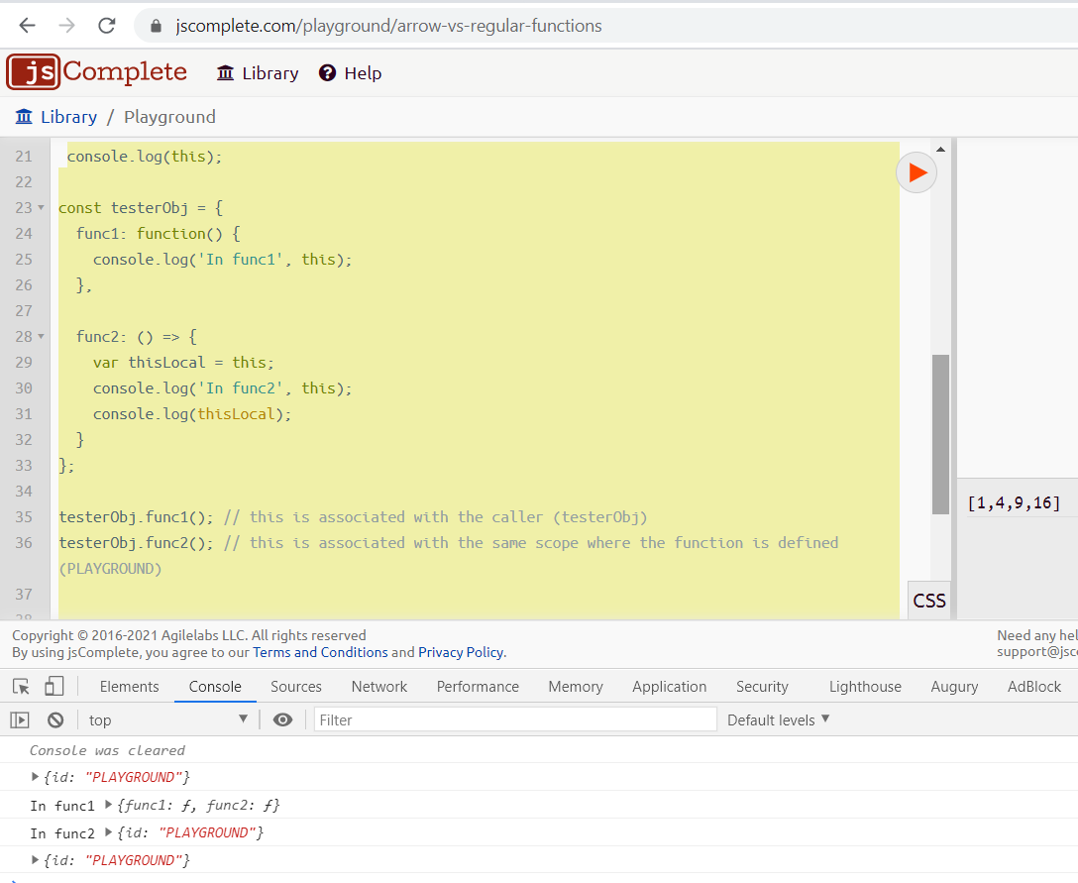

**Objects**

Defining an object with object literals

/*

const obj = {

key: value

};

*/

**const** mystery **=** 'answer'**;**

**const** InverseOfPI **=** 1 **/** Math**.**PI**;**

**const** obj **=** **{**

p1**:** 10**,**

p2**:** 20**,**

f1**()** **{},**

f2**:** **()** **=>** **{},**

**[**mystery**]:** 42**,**

InverseOfPI**,**

**};**

console**.**log**(**obj**);**

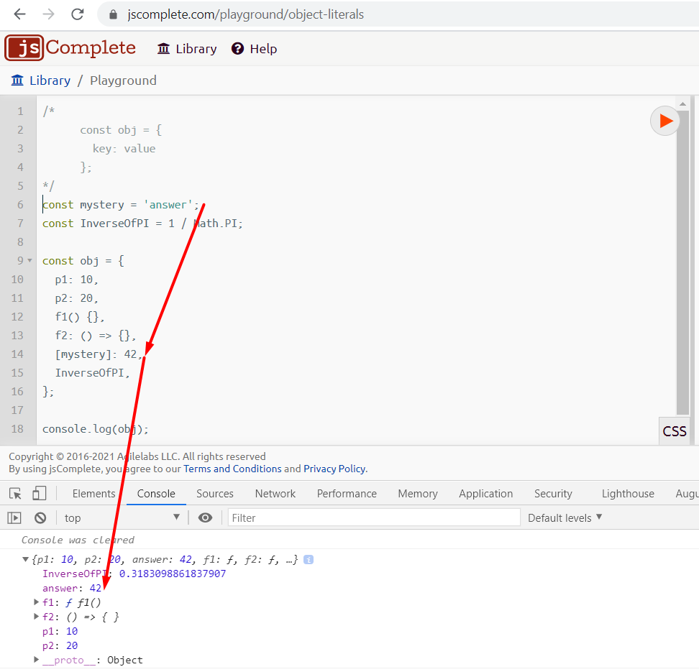

**Destructuring**

Destructuring assignment allows you to assign the properties of an array or object to variables using syntax that looks like array or object literals.

// const PI = Math.PI;

// const E = Math.E;

// const SQRT2 = Math.SQRT2;

// this code is equivalent

**const** **{**PI**,** E**,** SQRT2**}** **=** Math**;**

// Somewhere in a React App

// const {Component, Fragment, useState} = require('react');

// useState();

// const [first, second,, forth] = [10, 20, 30, 40];

**Destructuring and Function Arguments**

The basic syntax for destructuring is simple but using destructuring with function arguments can be a bit more difficult when those argument values should have default values.  The following is a function with arguments having default values:

**function** myFunction**(text** **=** ""**,** line **=** 0**,** truncate **=** 100**)** **{**

// With default values, we can avoid a bunch of:

**text** **=** **text** **||** ""**;**

line **=** line **||** 0**;**

truncate **=** truncate **||** 100**;**

**}**

Regardless of language, if a function takes more than ~3 parameters, it's probably best to pass in an object name options or config that contains possible key/values; the equivalent would look like:

**function** myFunction**(**config**)** **{**

**}**

// Usage

myFunction**({**

**text:** "Some value"**,**

line**:** 0**,**

truncate**:** 100

**})**

What if you want to use destructuring in JavaScript function arguments though?  The following function signature would become:

**function** myFunction**({** **text,** line**,** truncate **})** **{**

**}**

If you want to define defaults in the function configuration, you'd use the following:

**function** myFunction**({**

**text** **=** ""**,**

line **=** 0**,**

truncate **=** 100

**}** **=** **{})** **{**

// Even if the passed in object is missing a given key, the default is used!

**}**

Setting a default with = { } is important; with no default the following example would error:

TypeError**:** Cannot destructure property `key` **of** 'undefined' or 'null'

**Rest and Spread**

The spread operator allows us to spread the value of an array (or any iterable) across zero or more arguments in a function or elements in an array (or any iterable).

**const** **[**first**,** **...**restOfItems**]** **=** **[**10**,** 20**,** 30**,** 40**];**

console**.**log**(**first**);** // 10

console**.**log**(**restOfItems**);** // [20, 30, 40]

**const** data **=** **{**

temp1**:** '001'**,**

temp2**:** '002'**,**

firstName**:** 'John'**,**

lastName**:** 'Doe'**,**

**};**

**const** **{**temp1**,** temp2**,** **...**person**}** **=** data**;**

console**.**log**(**person**);**

**const** newArray **=** **[...**restOfItems**];** // shallow copy of restOfItems

**const** newObject **=** **{**

**...**person

**}** // shallow copy of person

**it works with objects as well**

**const** obj1 **=** **{**'name'**:** 'Petro'**,** 'lastName'**:** 'Ficci'**};**

**const** obj2 **=** **{**'age'**:** 30**};**

**const** obj3 **=** **{**'address'**:** 'abc-123'**,** **...**obj1**,** **...**obj2**,** 'country'**:** 'us'**};**

console**.**log**(**obj3**);** // {address: "abc-123", name: "Petro", lastName: "Ficci", age: 30, country: "us"}

The **rest parameter** allows us to pass an indefinite number of parameters to a function and access them in an array.

// Rest parameter

**function** mult**(...**args**)** **{**

console**.**log**(**args**.**reduce**((**acc**,** currValue**)** **=>** acc **\*** currValue**));**

**}**

mult**(**4**,** 2**);** // outputs 8

mult**(**4**,** 2**,** 3**);** // outputs 24

**Template strings**

**const** greeting **=** "Hello World"**;**

**const** answer **=** 'Forty Two'**;**

**const** html **=** `

<div>

${Math.random()}

</div>

`**;**

**Map function**

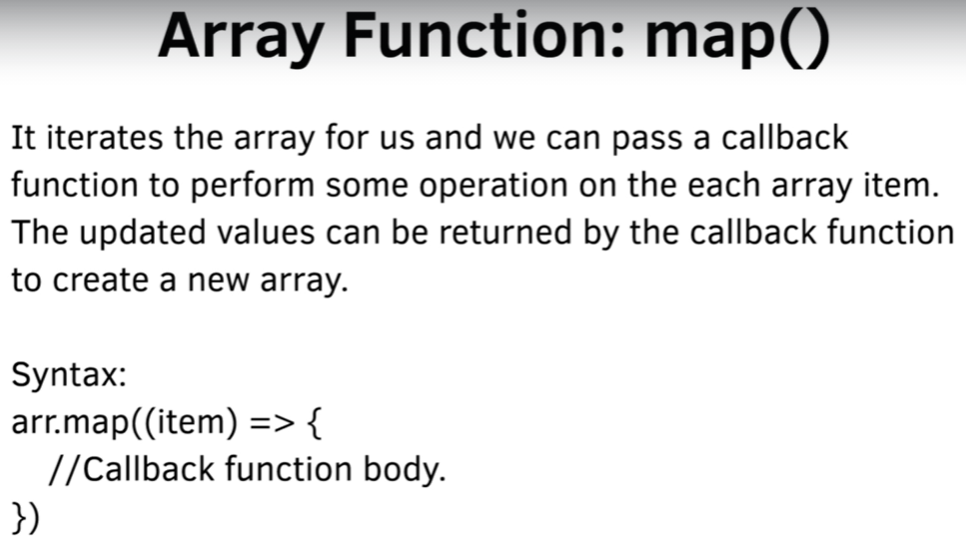

**const** arr1 **=** **[**1**,** 2**,** 3**,** 4**,** 5**];**

**const** arr2 **=** arr1**.**map**((**data**,** pos**)** **=>** **{**

console**.**log**(**`Item at position ${pos + 1} is ${data}`**);**

**return** data **\*** 2**;**

**});**

console**.**log**(**arr2**);**

**const** arrObj1 **=** **[{**'name'**:** 'Petro'**,** 'lastName'**:** 'Ficci'**,** 'age'**:** 30**},** **{**'name'**:** 'Luis'**,** 'lastName'**:** 'Perez'**,** 'age'**:** 25**},** **{**'name'**:** 'Clara'**,** 'lastName'**:** 'Rodriguez'**,** 'age'**:** 36**}];**

**const** arrObj2 **=** arrObj1**.**map**((**data**)** **=>** **{**

**return** **{**fullName**:** `${data.name} ${data.lastName}`**,** **status:** 'Processed'**};**

**});**

console**.**log**(**arrObj2**);**

**Reduce**

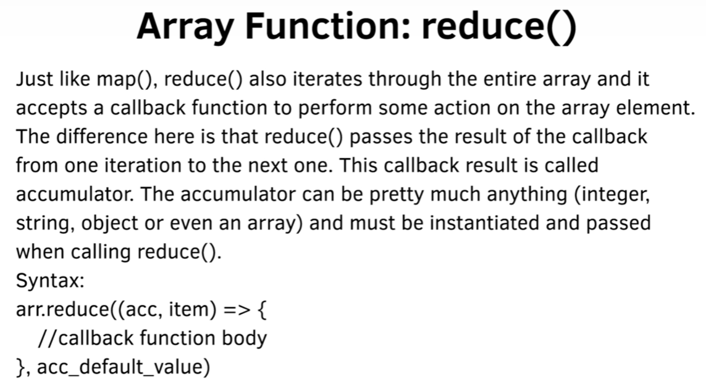

// Person array with name and Age

**const** person **=** **[**

**{**

name**:** 'Jim'**,**

color**:** 'blue'**,**

age**:** 22**,**

**},**

**{**

name**:** 'Sam'**,**

color**:** 'blue'**,**

age**:** 33**,**

**},**

**{**

name**:** 'Eddie'**,**

color**:** 'green'**,**

age**:** 77**,**

**},**

**];**

// Add their sum of ages

**const** sumOfAges **=** person**.**reduce**((**sum**,** currentValue**)** **=>** **{**

**return** sum **+** currentValue**.**age**;**

**},** 0**);**

console**.**log**(**sumOfAges**);** // 132

**Filter:**

// Person array with name and Age

**const** person **=** **[**

**{**

name**:** 'Jim'**,**

color**:** 'blue'**,**

age**:** 22**,**

**},**

**{**

name**:** 'Sam'**,**

color**:** 'blue'**,**

age**:** 33**,**

**},**

**{**

name**:** 'Eddie'**,**

color**:** 'green'**,**

age**:** 77**,**

**},**

**];**

**const** olders **=** person**.**filter**(**item **=>** **{**

**return** item**.**age **>** 60

**});**

console**.**log**(**olders**);** //[{name: "Eddie", color: "green", age: 77}]

**Find and findIndex**

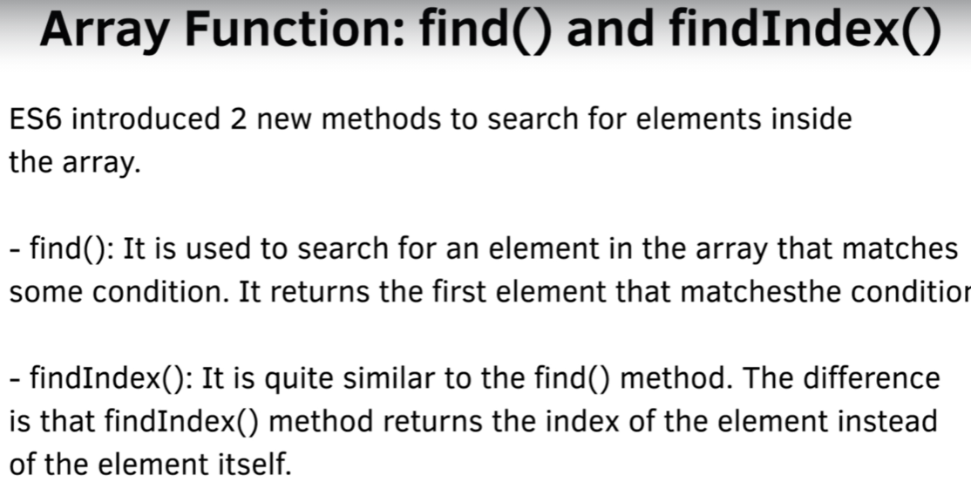

**const** arr1 **=** **[-**4**,** **-**2**,** 0 **,**1**,** 2**,** 3**,** 4**,** 5**,** 6**];**

**const** result1 **=** arr1**.**find**((**data**)** **=>** **{**

**return** data **%** 2 **===** 0**;**

**});**

**const** result2 **=** arr1**.**findIndex**((**data**)** **=>** **{**

**return** data **%** 2 **!==** 0**;**

**});**

console**.**log**(**result1**);** // -4, first match element

console**.**log**(**result2**);** // 3, index of element "1"

**Classes**

**class** Person **{**

**constructor(**name**)** **{**

**this.**name **=** name**;**

**}**

greet**()** **{**

console**.**log**(**`Hello ${this.name}!`**);**

**}**

**}**

**class** Student **extends** Person **{**

**constructor(**name**,** level**)** **{**

**super(**name**);**

**this.**level **=** level**;**

**}**

greet**()** **{**

console**.**log**(**`Hello ${this.name} from ${this.level}`**);**

**}**

**}**

**const** o1 **=** **new** Person**(**"Max"**);**

**const** o2 **=** **new** Student**(**"Tina"**,** "1st Grade"**);**

**const** o3 **=** **new** Student**(**"Mary"**,** "2nd Grade"**);**

o3**.**greet **=** **()** **=>** console**.**log**(**'I am special!'**);**

o1**.**greet**();**

o2**.**greet**();**

o3**.**greet**();**

**Promises and async/await**

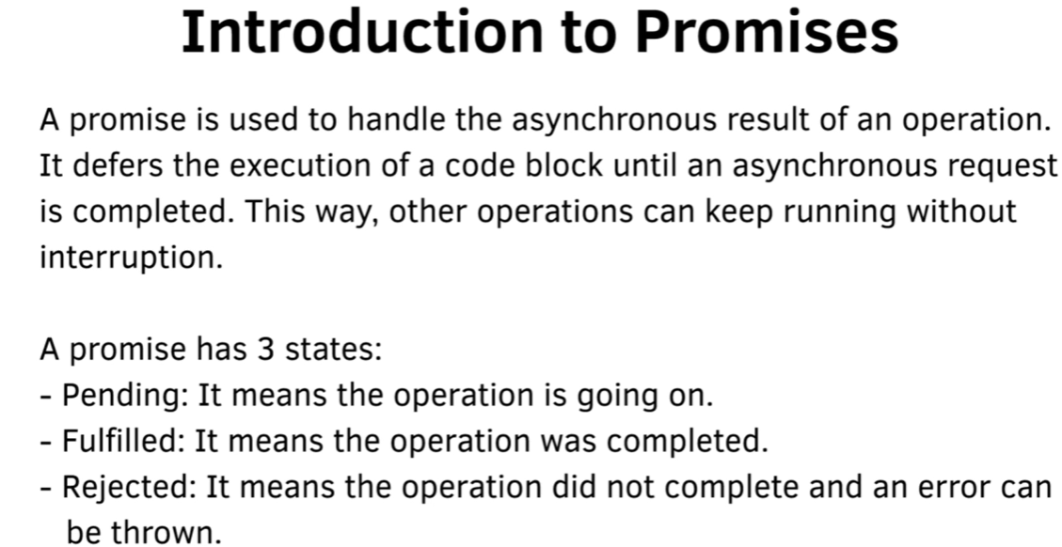

**const** getPosts **=** **new** Promise**((**resolve**,** reject**)** **=>** **{**

**const** req **=** **new** XMLHttpRequest**();**

req**.open(**'GET'**,** 'https://jsonplaceholder.typicode.com/posts'**);**

req**.onload** **=** **function()** **{**

**if** **(**req**.status** **===** 200**)** **{**

resolve**(**JSON**.**parse**(**req**.**response**));**

**}** **else** **{**

reject**(new** Error**(**`Call Failed: ${req.status} ${req.message}`**));**

**}**

**};**

req**.**send**();**

**})**

getPosts**.**then**(**result **=>** **{**

console**.**log**(**result**);**

**}).catch((**error**)** **=>** **{**

console**.**log**(**error**);**

**});**

// async await replaces then nesting

**const** executePromiseAsync **=** **async** **()** **=>** **{**

**const** resp **=** **await** getPosts**;**

**const** data **=** **await** resp**;**

console**.**log**(**data**);**

**};**

executePromiseAsync**().catch((**error**)** **=>** **{**

console**.**log**(**error**.**message**);**

**});**

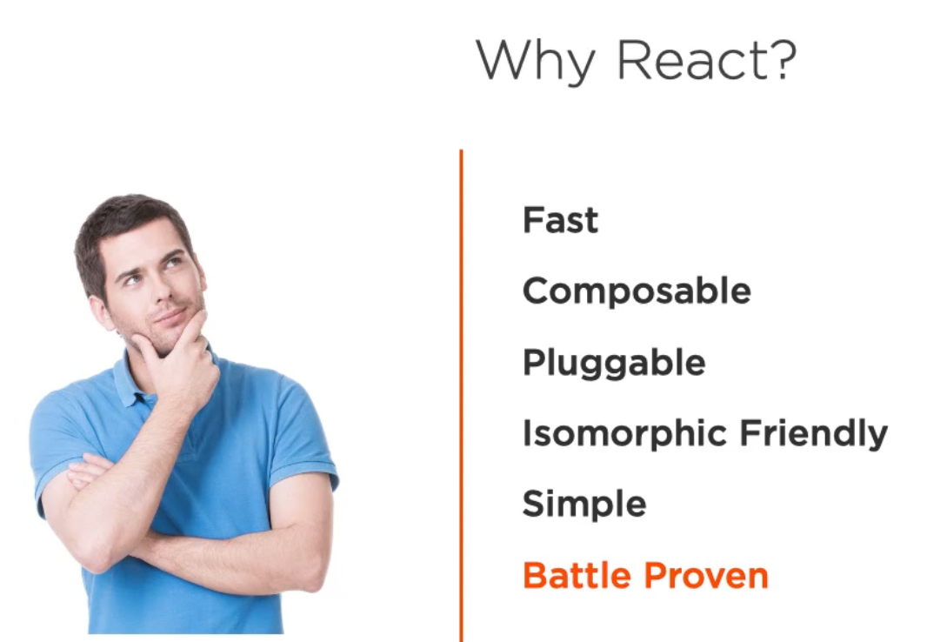

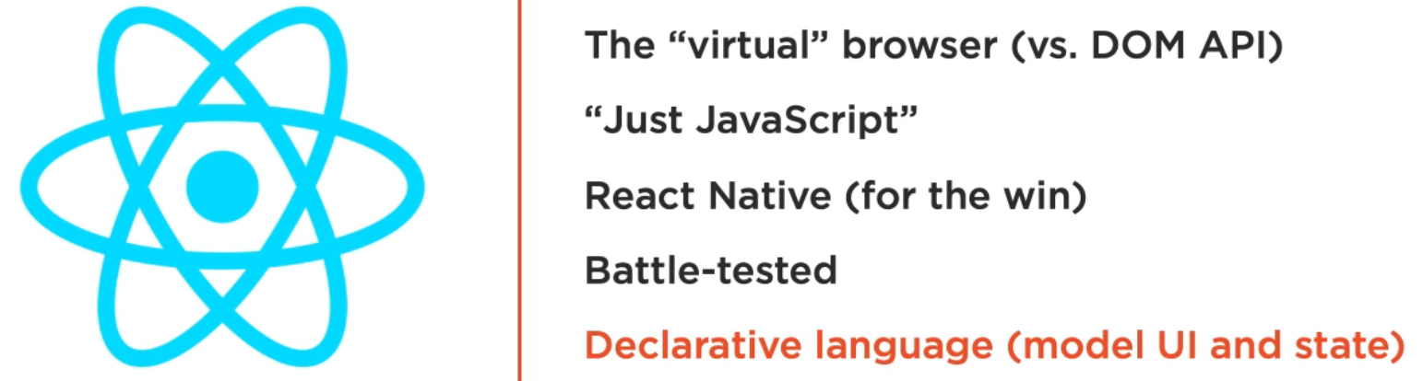

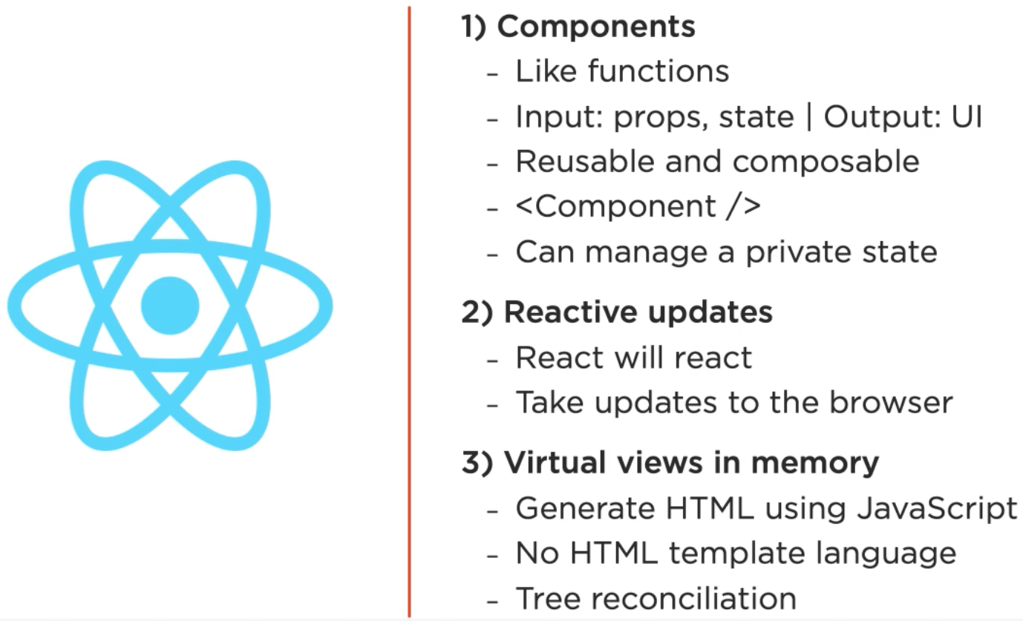

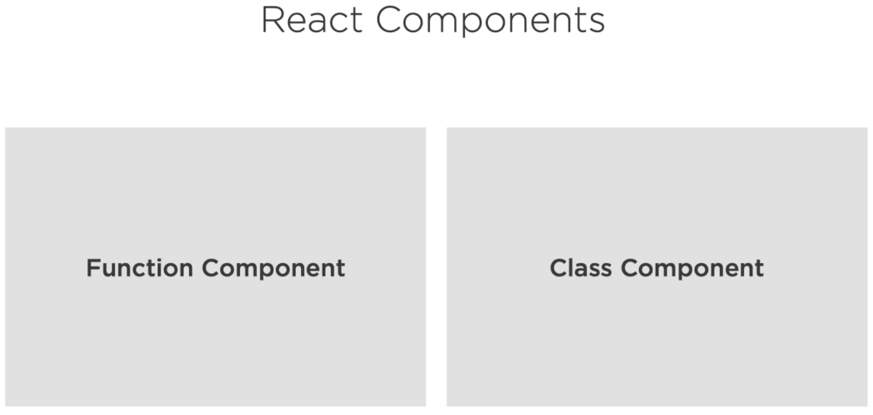

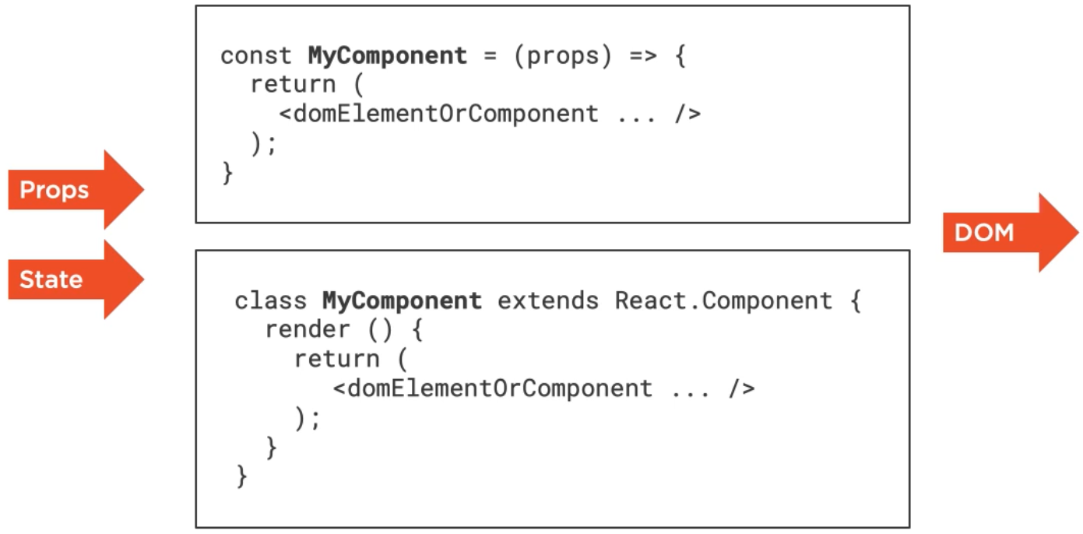

Props is immutable, components can only change its internal State not their properties

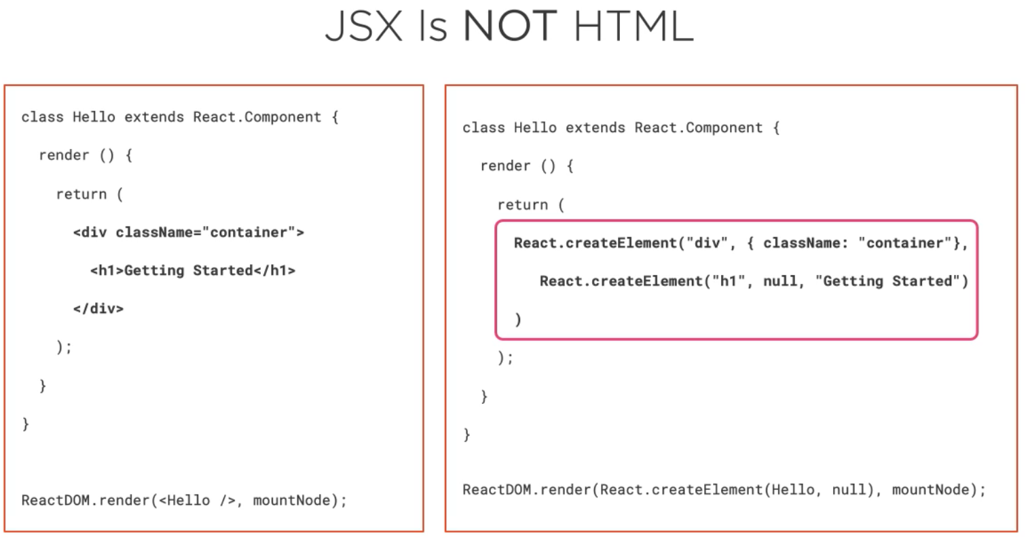

**function** Hello**()** **{**

// JSX code, the code will be converted by Babel to React API calls

**return** **<**div**>**Hello React**!</**div**>;**

**}**

ReactDOM**.**render**(**

// <Hello /> is the component to render, mountNode is the DOM element where Hello will be rendered

**<**Hello **/>,**

**document.**getElementById**(**'mountNode'**),**

**);**

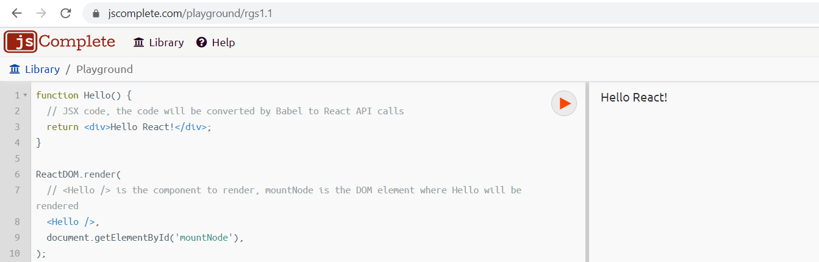

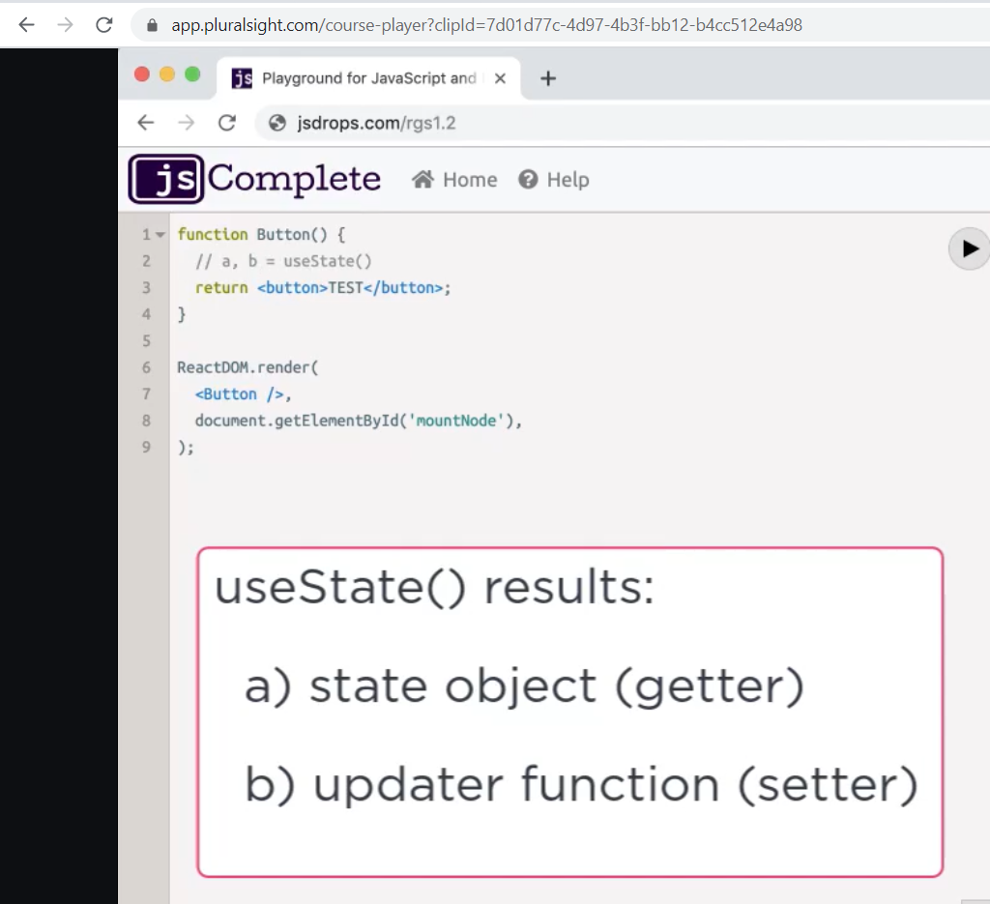

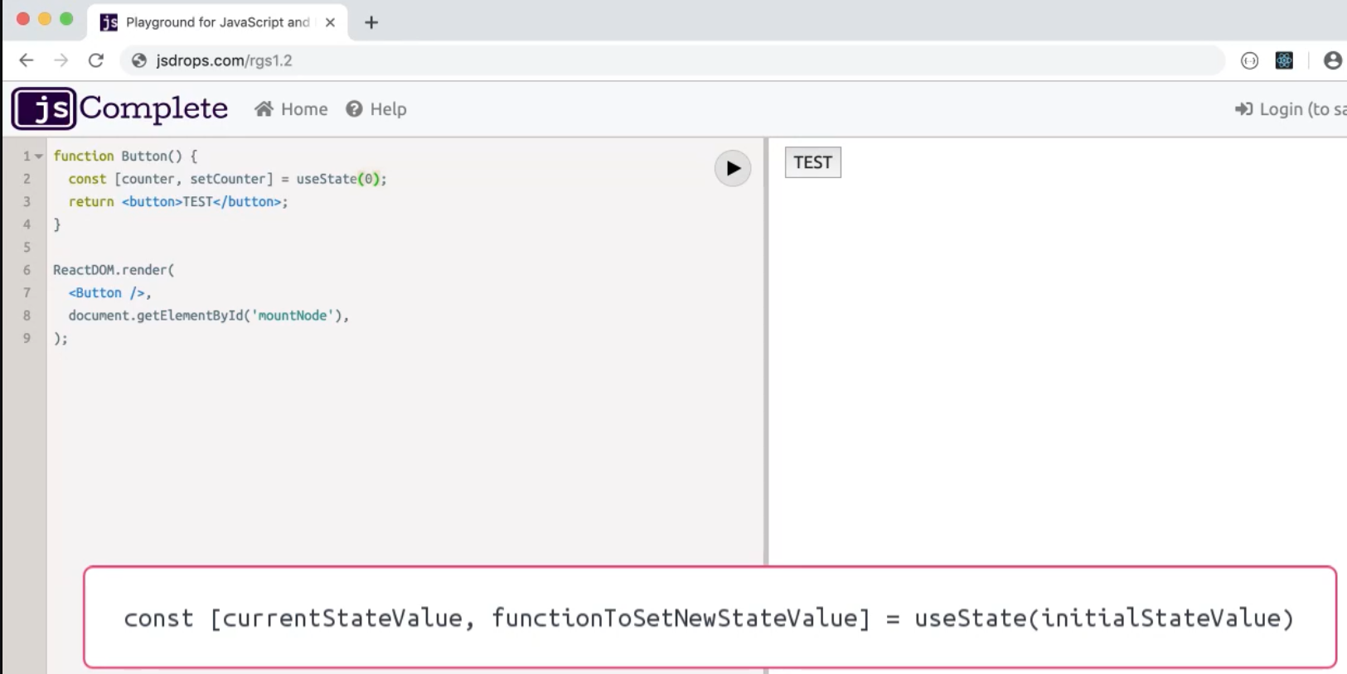

**function** Button**(**props**)** **{**

// we are returning a function call

**return** **(**

**<button**

// JSX can display dynamic expressions using {}

onClick**={**props**.**onClickFunction**}>** **+**1

**</button>**

**);**

**}**

**function** Display**(**props**)** **{**

// we are returning a function call

**return** **(**

**<**div**>**

**{**props**.**message**}**

**</**div**>**

**);**

**}**

**function** App**()** **{**

**const** initialValue **=** 0**;**

// useState is a global function React provides, returns an array

**const** **[**counter**,** setCounter**]** **=** useState**(**initialValue**);** //array destructuring

//click handler function needs to be defined inside this context because needs access to counter and setCounter

**const** incrementCounter **=** **()** **=>** setCounter**(**counter **+** 1**);**

// we are returning a function call

// onClickFunction and message are the arguments of props parameter of each function, it can contain values or functions

**return** **(**

**<**div**>**

**<**Button onClickFunction **=** **{**incrementCounter**}/>**

**<**Display message **=** **{**counter**}/>**

**</**div**>**

**);**

**}**

ReactDOM**.**render**(**

**<**App **/>,**

**document.**getElementById**(**'mountNode'**),**

**);**

Component Reusability

**function** Button**(**props**)** **{**

**const** handleClick **=** **()** **=>** props**.**onClickFunction**(**props**.**increment**);**

**return** **(**

**<button** onClick**={**handleClick**}>**

**+{**props**.**increment**}**

**</button>**

**);**

**}**

**function** Display**(**props**)** **{**

**return** **(**

**<**div**>{**props**.**message**}</**div**>**

**);**

**}**

**function** App**()** **{**

**const** **[**counter**,** setCounter**]** **=** useState**(**0**);**

**const** incrementCounter **=** **(**incrementValue**)** **=>** setCounter**(**counter **+** incrementValue**);**

**return** **(**

**<**div**>**

**<**Button onClickFunction**={**incrementCounter**}** increment**={**1**}** **/>**

**<**Button onClickFunction**={**incrementCounter**}** increment**={**5**}** **/>**

**<**Button onClickFunction**={**incrementCounter**}** increment**={**10**}** **/>**

**<**Button onClickFunction**={**incrementCounter**}** increment**={**100**}** **/>**

**<**Display message**={**counter**}/>**

**</**div**>**

**);**

**}**

ReactDOM**.**render**(**

**<**App **/>,**

**document.**getElementById**(**'mountNode'**),**

**);**

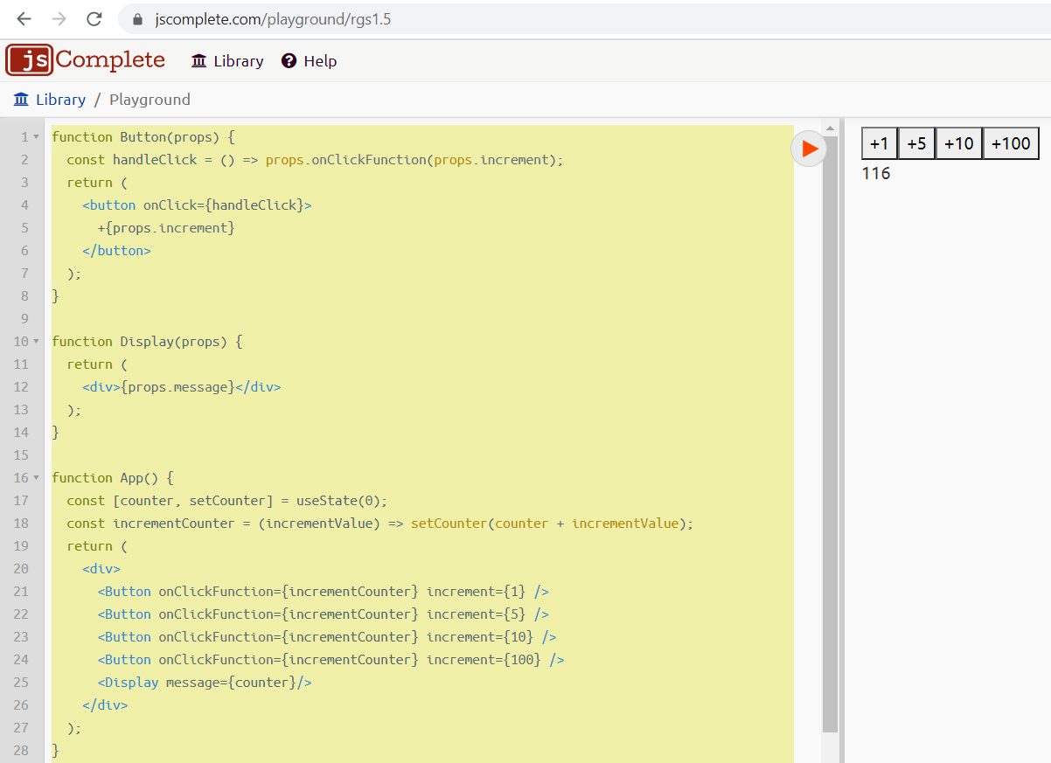

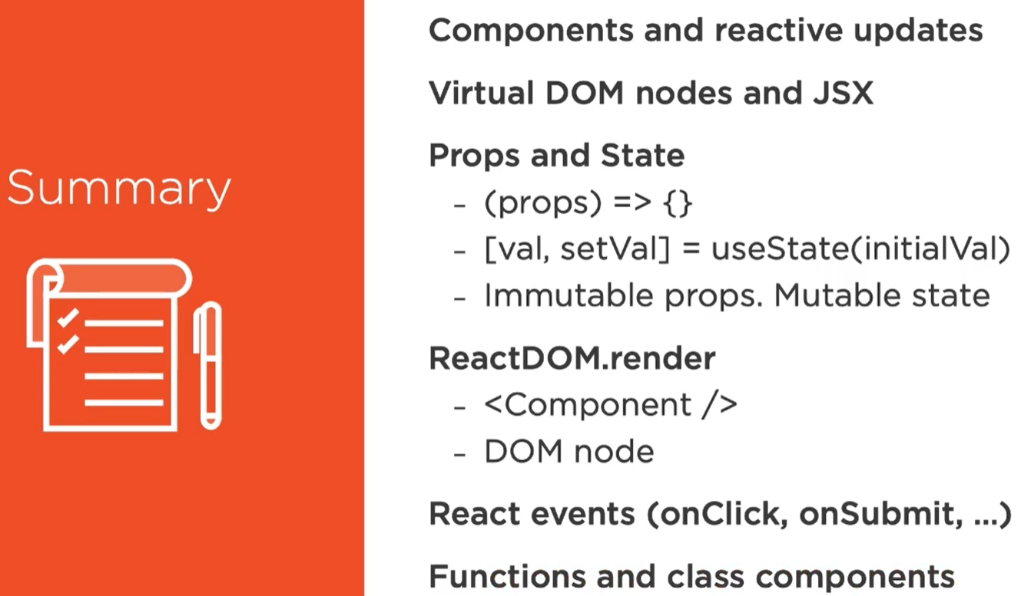

**Ejercicio de GitHub Cards**

// sophiebits, sebmarkbage, pperez, xs, tm, tj

/* function component

const App = ({title}) => (

<div className="header">{title}</div>

);

*/

// class component

**class** App **extends** React**.**Component **{**

/*

constructor(props) {

super(props);

this.state = {

profiles: []

};

}

*/

// this code is equivalent to constructor code

state **=** **{**

profiles**:** **[]**

**};**

addNewProfile **=** **(**profileData**)** **=>** **{**

console**.**log**(**profileData**);**

**this.**setState**(**prevState **=>** **({**

profiles**:** **[...**prevState**.**profiles**,** profileData**]**

**}));**

**};**

render**()** **{**

**return** **(**

**<**div className**=**"header"**>**

**{this.**props**.**title**}**

**<**Form onSubmit**={this.**addNewProfile**}/>**

**<**CardList profiles**={this.**state**.**profiles**}/>**

**</**div**>**

**);**

**}**

**}**

**class** Card **extends** React**.**Component **{**

render**()** **{**

**const** testProfile **=** **this.**props**;**

**return** **(**

**<**div className**=**"github-profile"**>**

**<**img src**={**testProfile**.**avatar_url**}** **/>**

**<**div className**=**"info"**>**

**<**div className**=**"name"**>** **{**testProfile**.**name**}** **</**div**>**

**<**div className**=**"company"**>** **{**testProfile**.**company**}** **</**div**>**

**</**div**>**

**</**div**>**

**);**

**}**

**}**

// {testData.map(profile => <Card {...profile} />)} map needs a function, so <Card {...profile} /> destructures profile

// and the final result is that Card component receives 3 props

**const** CardList **=** **(**props**)** **=>** **(**

**<**div**>**

**{**props**.**profiles**.**map**(**profile **=>** **<**Card key**={**profile**.**id**}** **{...**profile**}** **/>)}**

**</**div**>**

**)**

**class** Form **extends** React**.**Component **{**

//userNameInput = React.createRef();

//<input type="text" placeholder="GitHub username" ref={this.userNameInput} required/>

state **=** **{**

userName**:** ''

**};**

handleSubmit **=** **async** **(event)** **=>** **{**

**event.**preventDefault**();**

//console.log(this.userNameInput.current.value);

**const** resp **=** **await** axios**.**get**(**`https://api.github.com/users/${this.state.userName}`**);**

**this.**props**.**onSubmit**(**resp**.**data**);**

**this.**setState**({**userName**:** ''**});**

**}**

render**()** **{**

**return** **(**

**<form** onSubmit**={this.**handleSubmit**}>**

**<**input type**=**"text"

value**={this.**state**.**userName**}**

onChange**={event** **=>** **this.**setState**({**userName**:** **event.**target**.**value**})}**

placeholder**=**"GitHub username"

required**/>**

**<button>**Add card**</button>**

**</form>**

**);**

**}**

**}**

ReactDOM**.**render**(**

**<**App title**=**"The GitHub Cards App" **/>,**

mountNode**,**

**);**

**CSS**

/* Nerdy secret: You can use "less" below! Don't tell anybody... */

**.**github-profile **{**

**margin: 1rem;**

img **{**

**width: 75px;**

**}**

**.**info **{**

**display: inline-block;**

**margin-left: 12px;**

**.name {**

**font-size: 1.25rem;**

**font-weight: bold;**

**}**

**}**

**}**

form **{**

**border: thin solid #ddd;**

**background-color: #fbfbfb;**

**padding: 2rem;**

**margin-bottom: 2rem;**

**display: flex;**

**justify-content: center;**

**}**

**.**header **{**

**text-align: center;**

**font-size: 1.5rem;**

**margin-bottom: 1rem;**

**}**

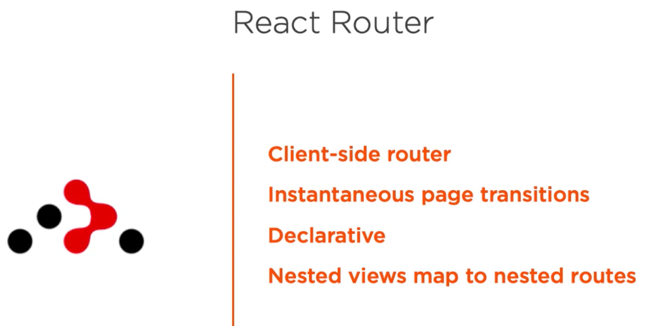

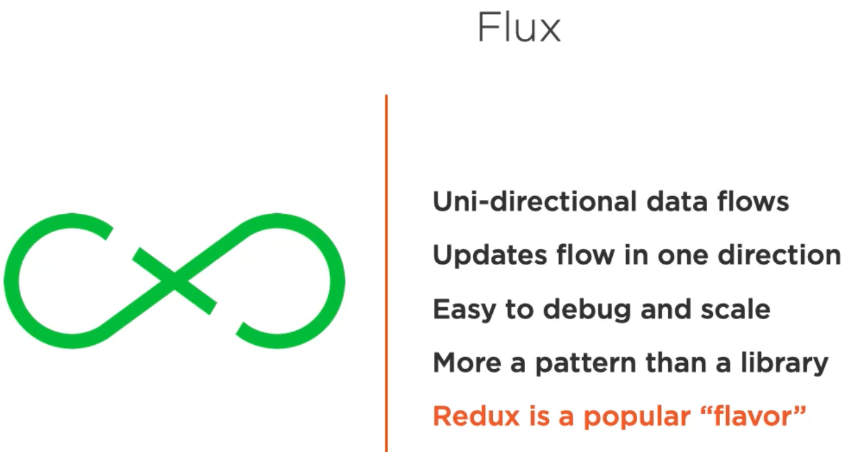

**Environment setup:**

Install Node, to check node version: node -v

Execute “npx create-react-app ps-flux” where ps-flux is application’s name

After installation, open directory ps-flux in VS, run “npm -start” to start the application

Package.json contains configurations and dependencies

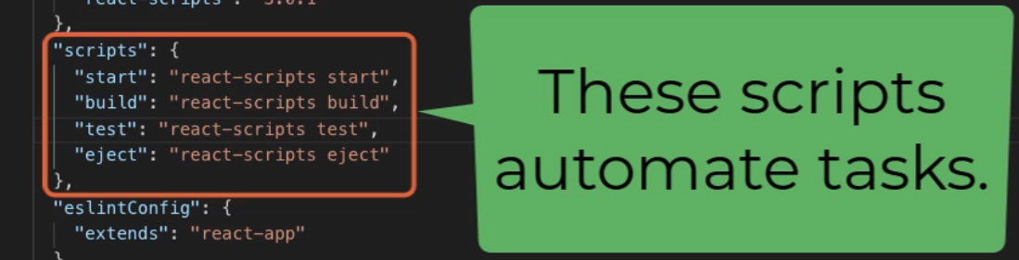 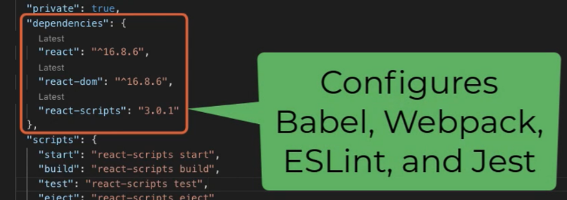

Index.js is the application’s entry point.

Installing additional dependencies: run “npm install flux --legacy-peer-deps react-router-dom@5.0.0 [bootstrap@4.3.1](mailto:bootstrap@4.3.1)” note we are installing multiple packages using the same command.

You can delete all files on source folder except for index.js, delete all file content to start with a clean base.

import "bootstrap/dist/css/bootstrap.min.css";

adds bootstrap to app

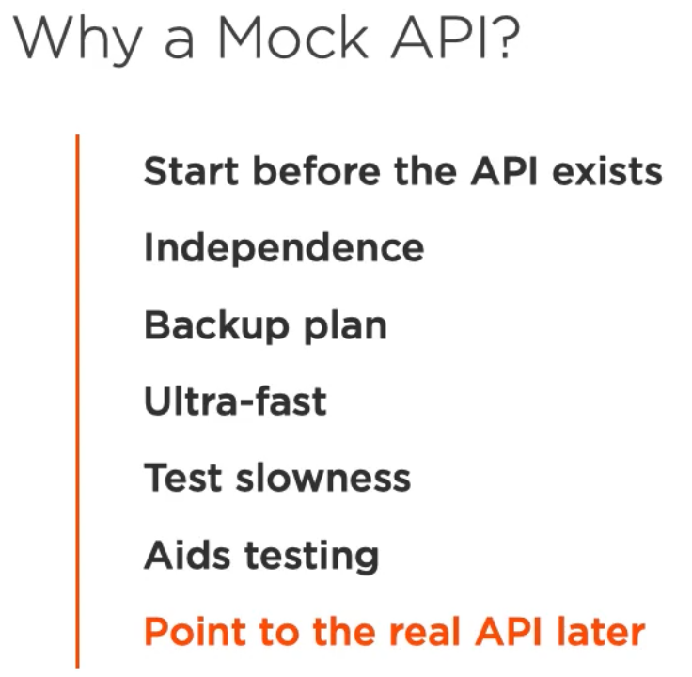

Installing packages for mock api : run “npm install -D cross-env@5.2.0 npm-run-all@4.1.5 [json-server@0.15.0](mailto:json-server@0.15.0)”

In package.json, add this lines inside scripts section:

 "prestart:api": "node tools/createMockDb.js",

    "start:api": "node tools/apiServer.js",

Run “npm run start:api” to start the mock api. An enhancement is to add a new script that runs at the same time the development and api scripts:

   "start": "run-p start:dev start:api",

    "start:dev": "react-scripts start",

    "prestart:api": "node tools/createMockDb.js",

    "start:api": "node tools/apiServer.js",

JSX

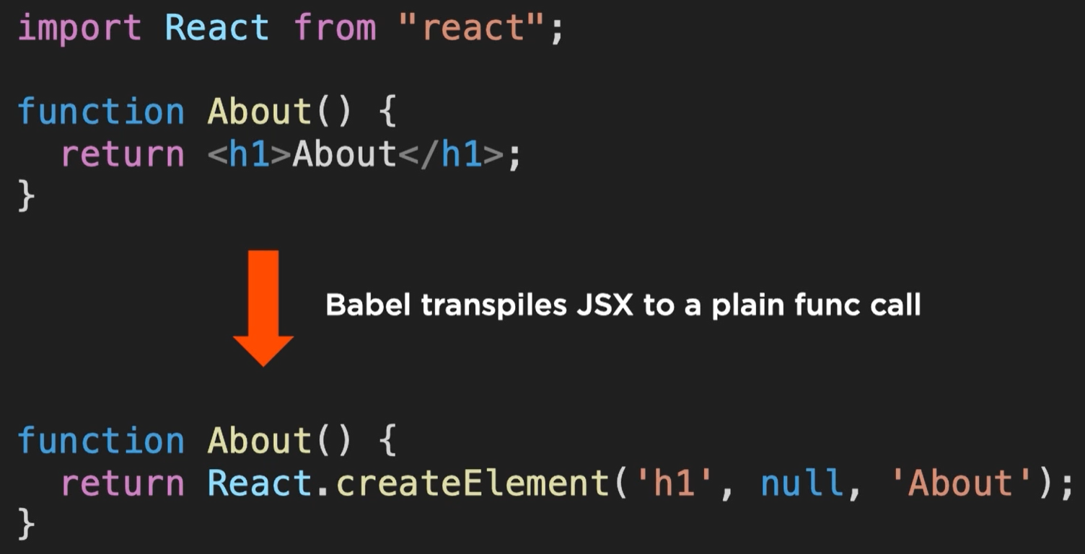 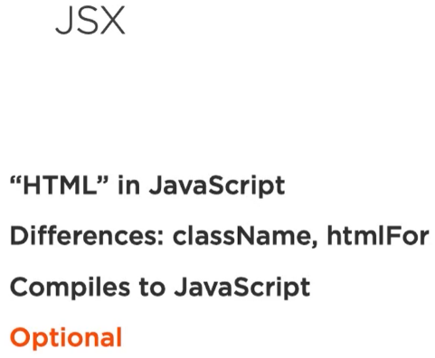

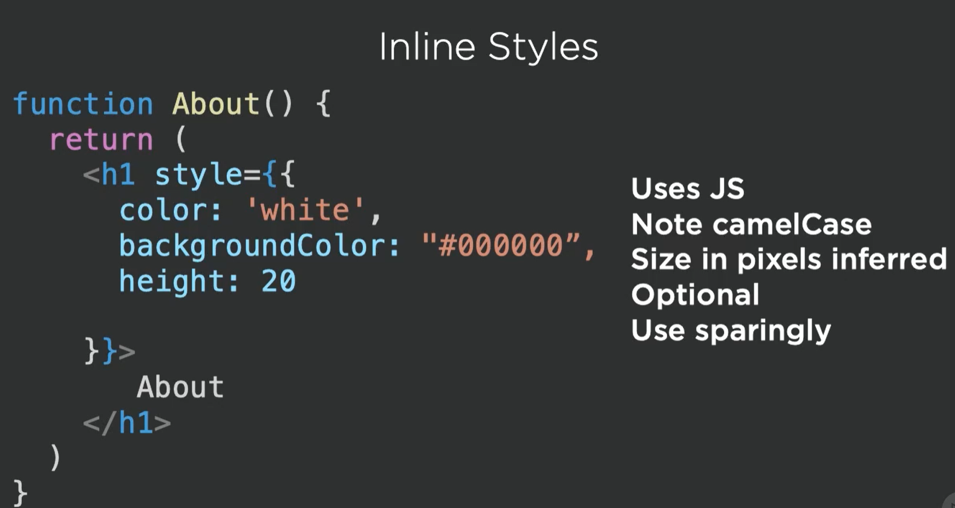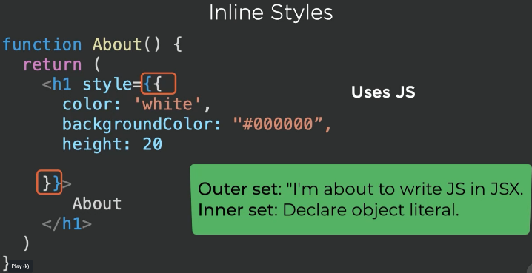

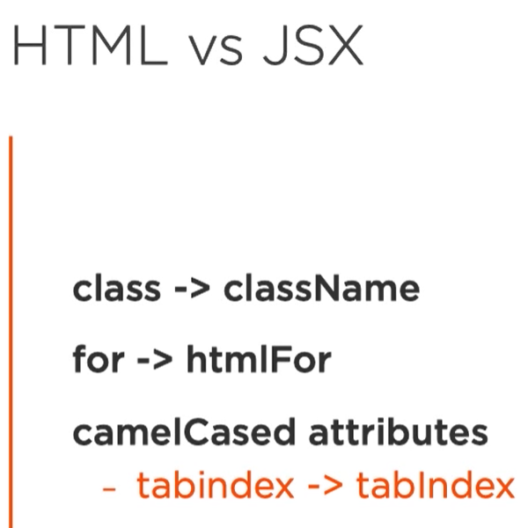

Virtual DOM



Components

4 ways to create react components:

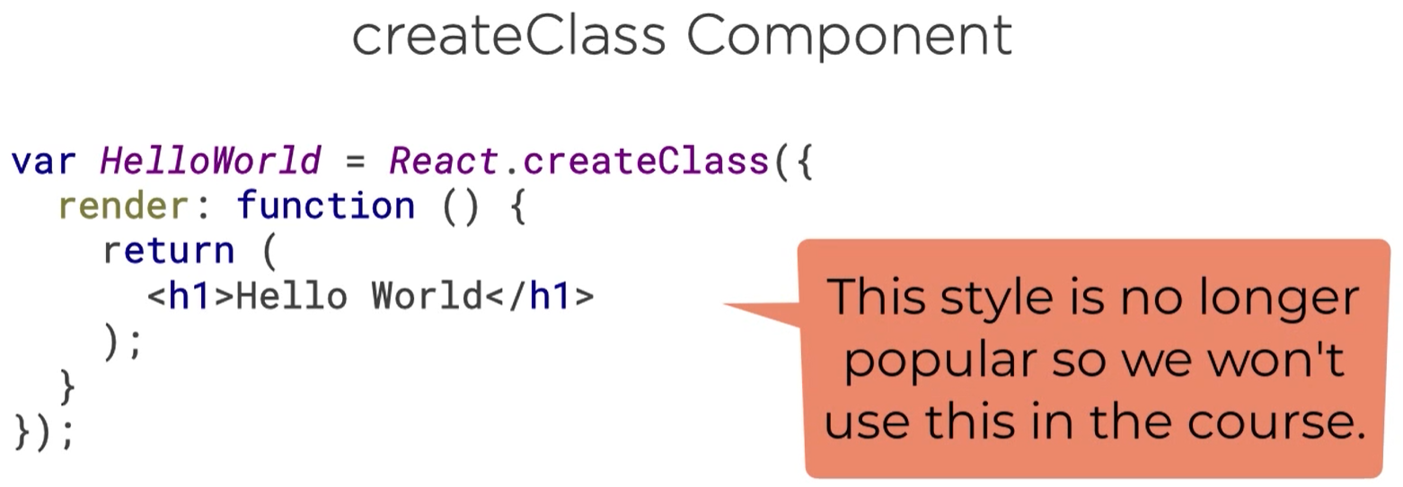

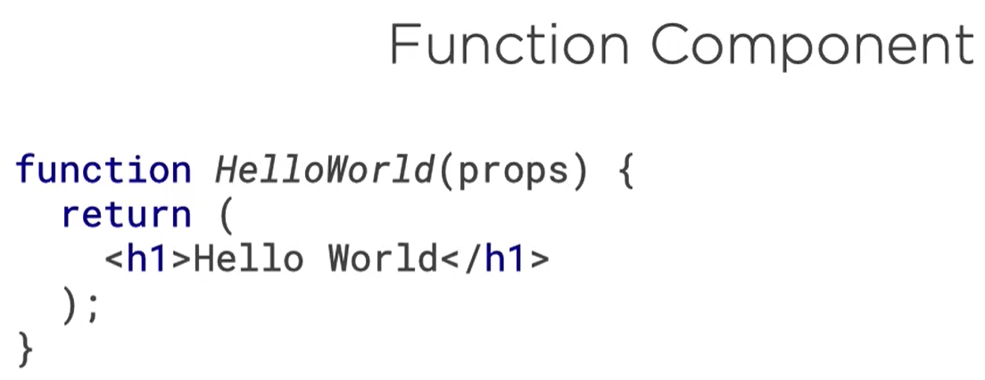 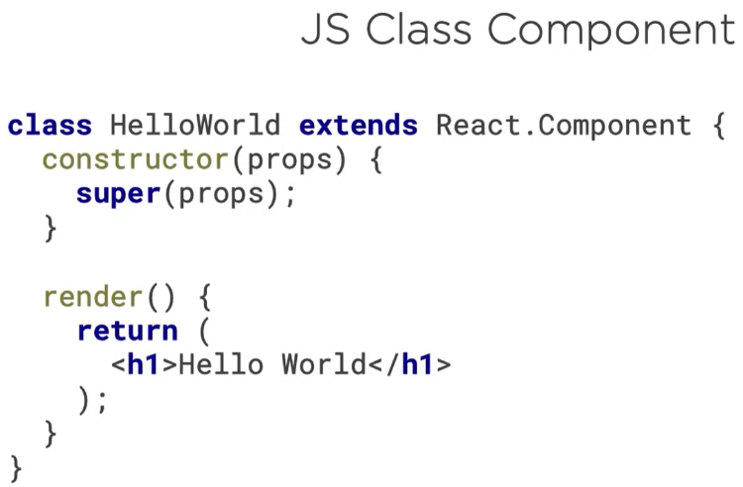  
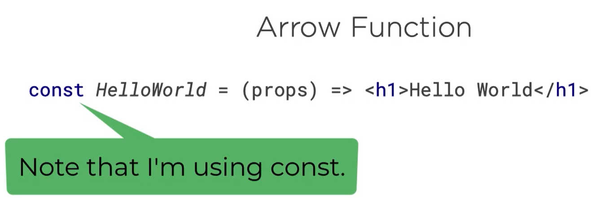

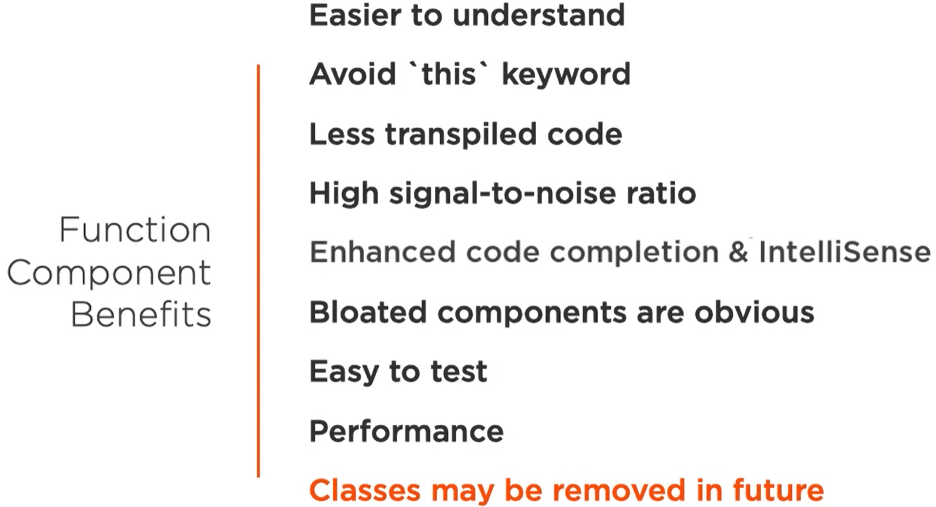

Props and State

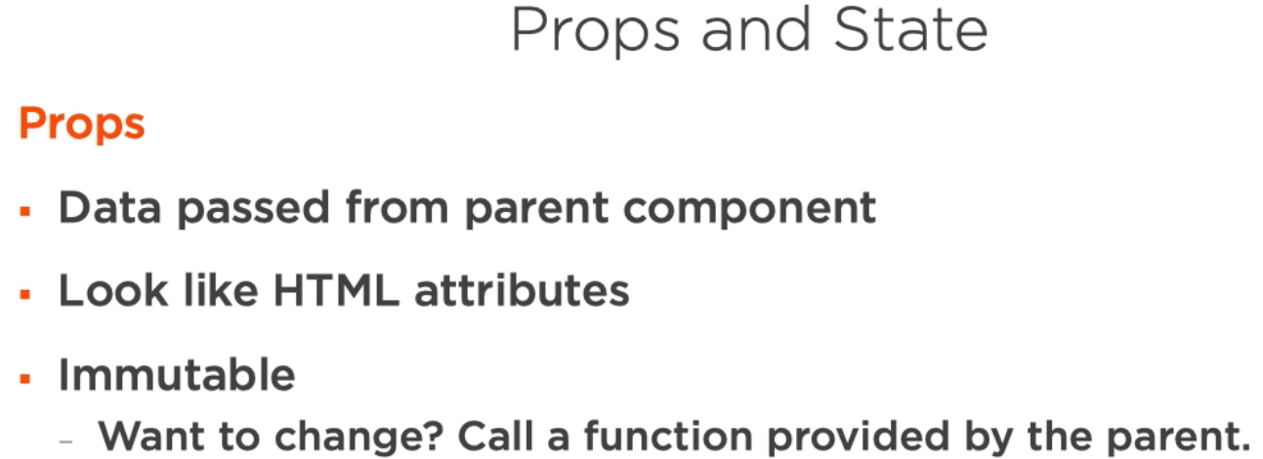 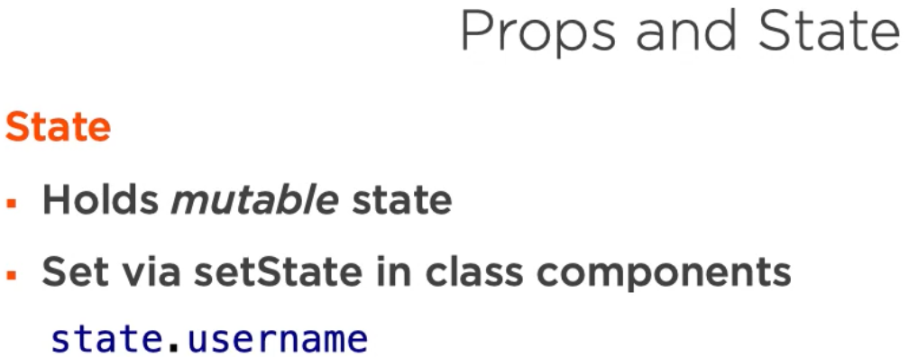

Lifecycle methods, apply for class components, for function methods use hooks

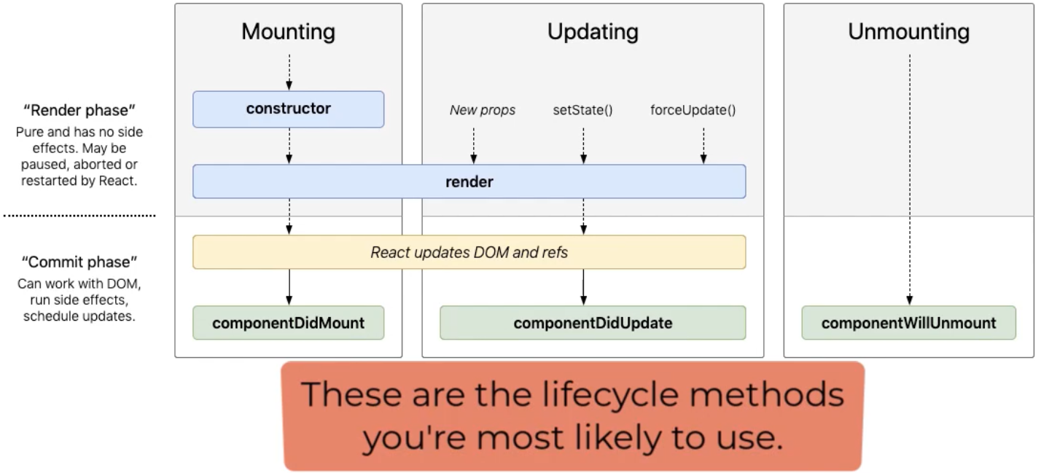

* **constructor** executes before the component is mounted, useful for initialize state, bind event methods, for initialize state can use class fields too.
* **render** executes anytime state and props change, useful for declare the markup the component outputs.
* **componentDidMount** executes after component is mounted, useful for access DOM, set up subscriptions, integrate with frameworks, set timers, make http calls.
* **componentDidUpdate** executes after component’s updates are flushed to the DOM, useful for work with the DOM after an update.
* **componentWillUpdate** executes inmmediately before component is removed from the DOM, useful for cleanup.

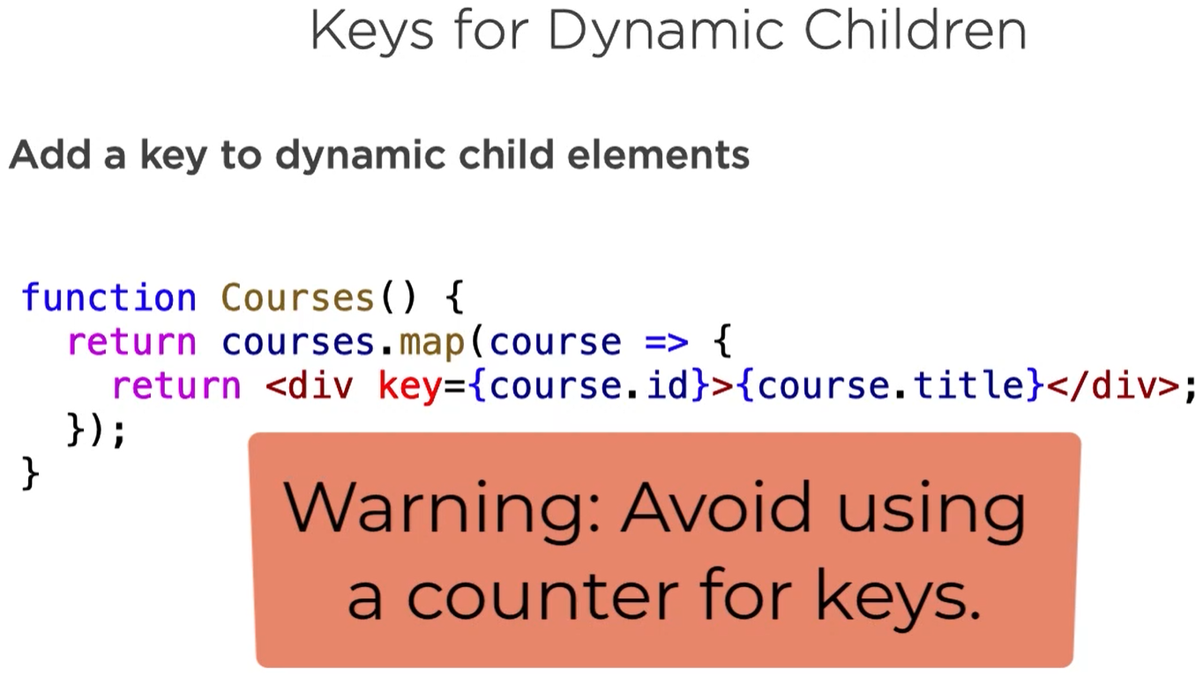

Hooks

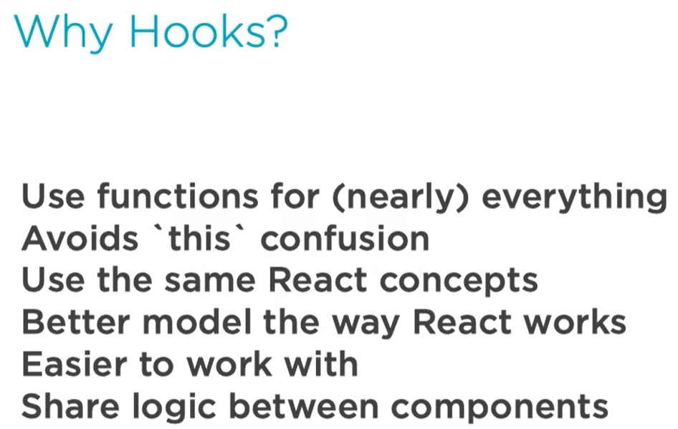

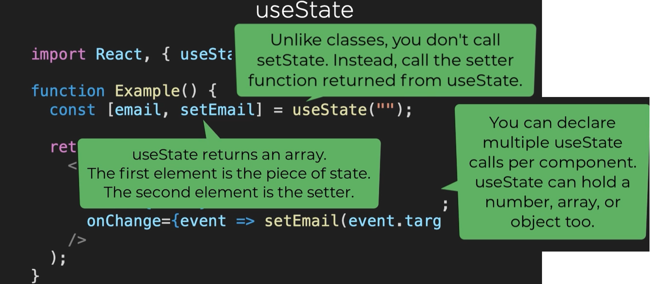

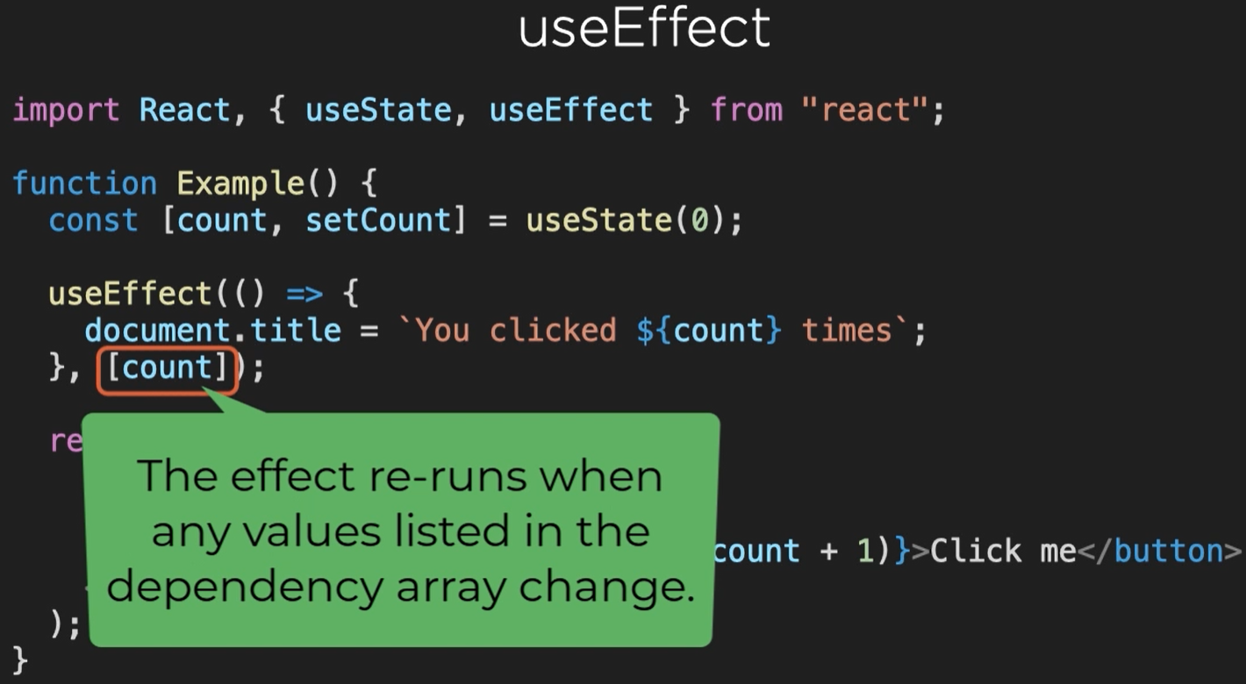

"Side Effect" is not a react-specific term. It is a general concept about behaviours of functions. A function is said to have side effect if it tries to modify anything outside its body. For example, if it modifies a global variable, then it is a side effect. If it makes a network call, it is a side effect as well.

**What does useEffect do?** By using this Hook, you tell React that your component needs to do something after render. React will remember the function you passed (we’ll refer to it as our “effect”), and call it later after performing the DOM updates. In this effect, we set the document title, but we could also perform data fetching or call some other imperative API.

**Why is useEffect called inside a component?** Placing useEffect inside the component lets us access the count state variable (or any props) right from the effect. We don’t need a special API to read it — it’s already in the function scope. Hooks embrace JavaScript closures and avoid introducing React-specific APIs where JavaScript already provides a solution.

**Does useEffect run after every render?** Yes! By default, it runs both after the first render and after every update. Instead of thinking in terms of “mounting” and “updating”, you might find it easier to think that effects happen “after render”. React guarantees the DOM has been updated by the time it runs the effects.

If you’re familiar with React class lifecycle methods, you can think of useEffect Hook as **componentDidMount, componentDidUpdate, and componentWillUnmount combined**.

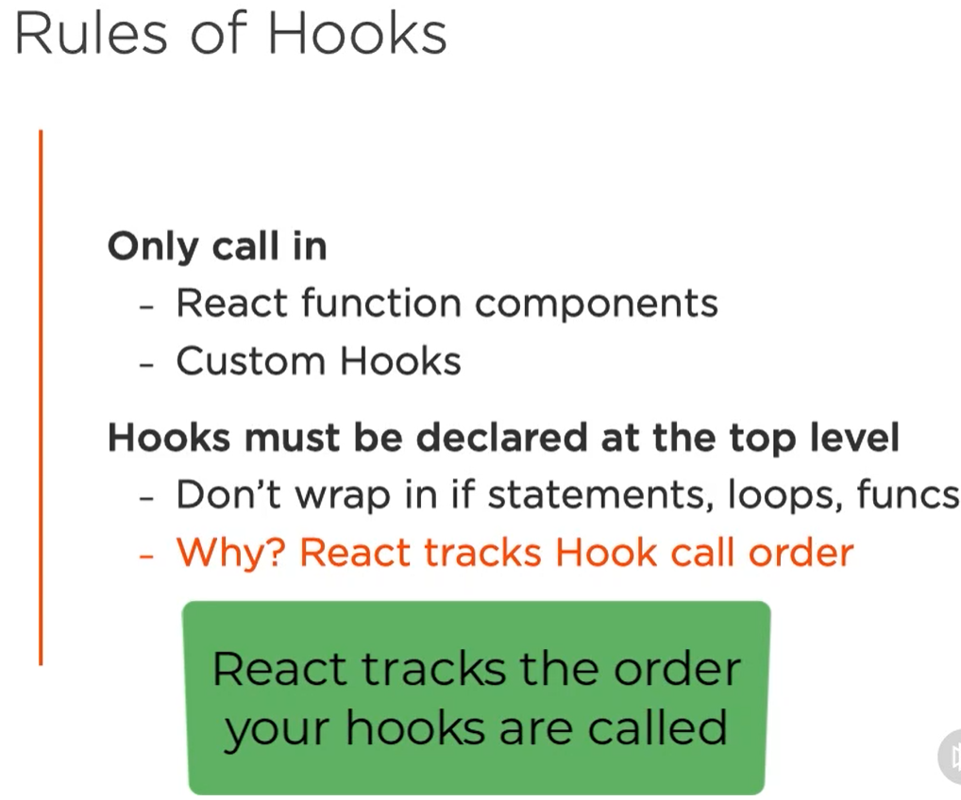

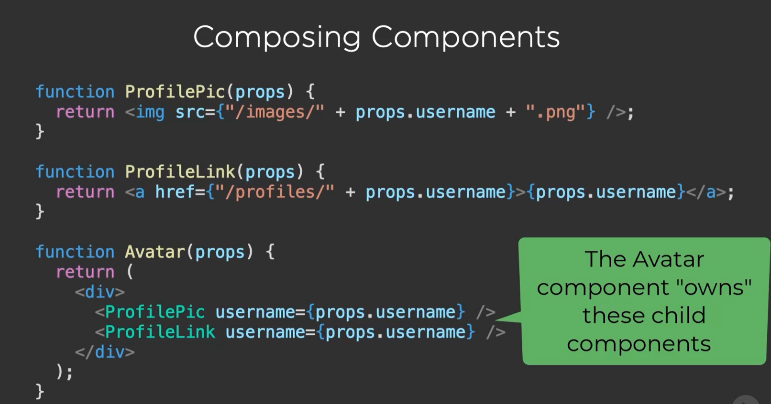

Controller view is a component that has child components. Is a way of composing functionality by nesting children components.

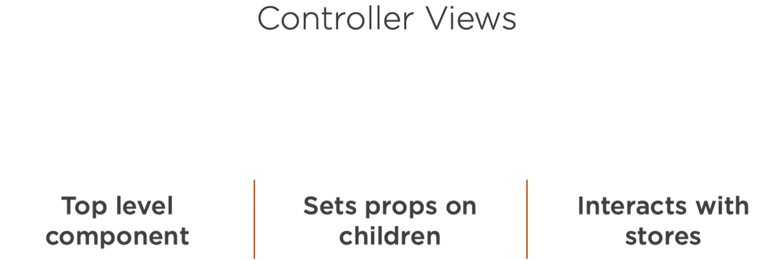

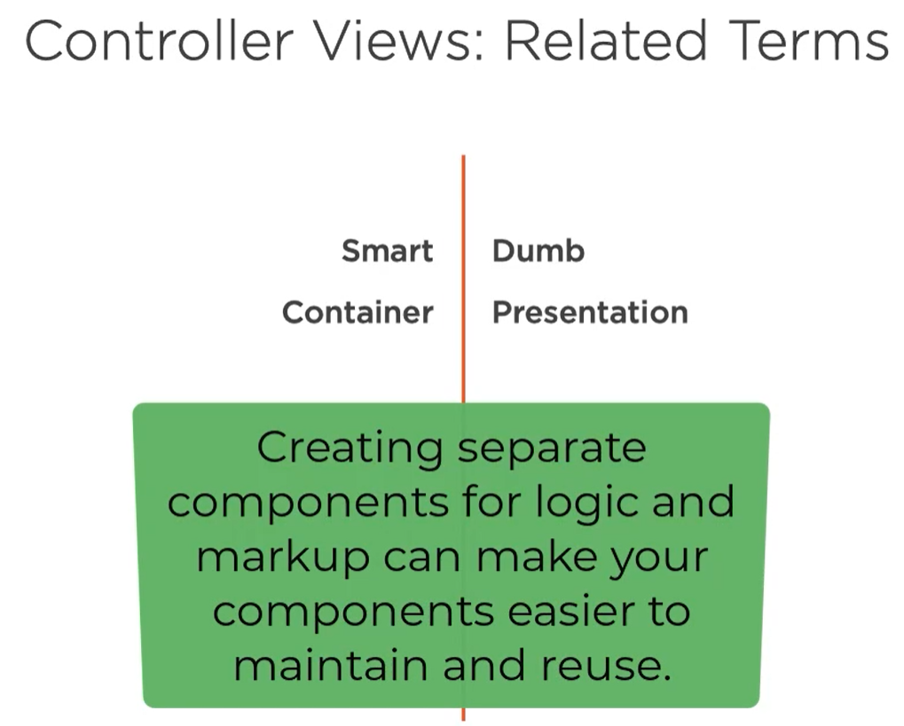

PropTypes

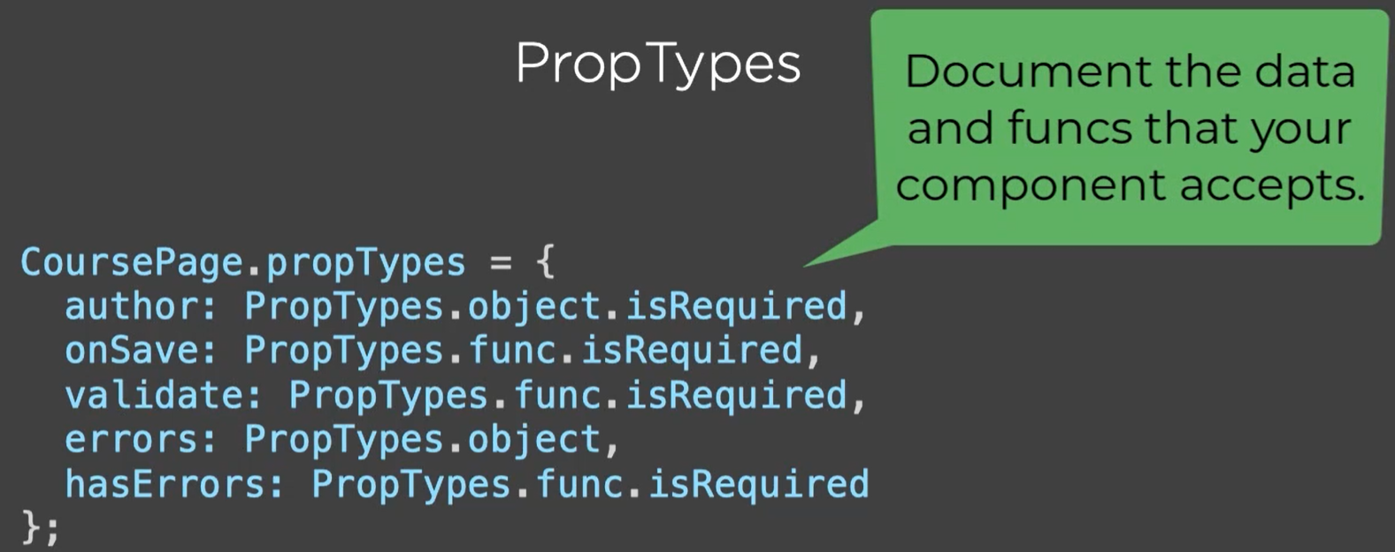

React Router

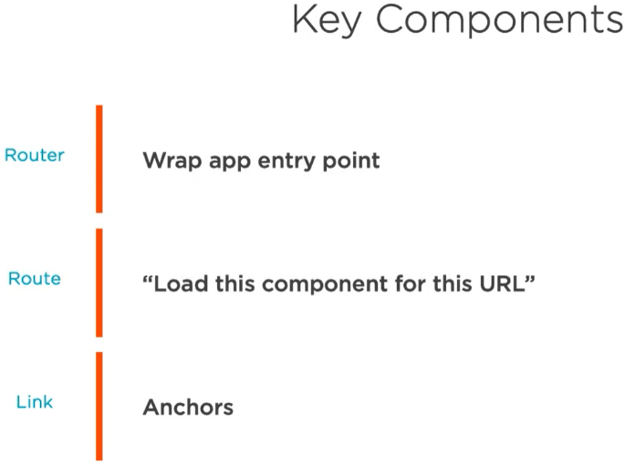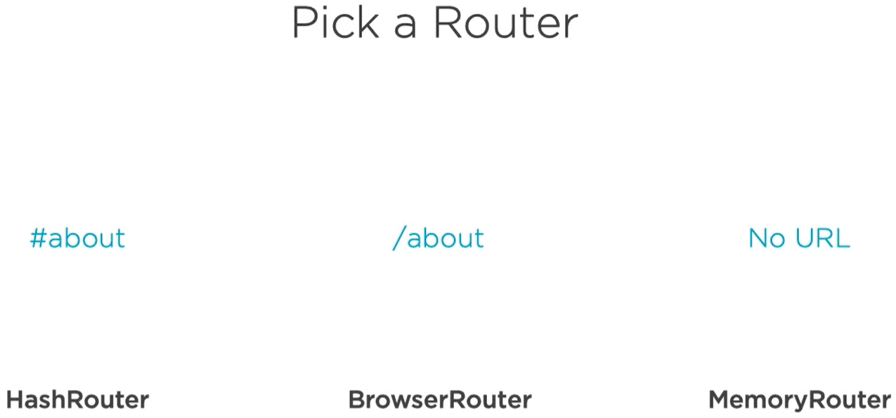  
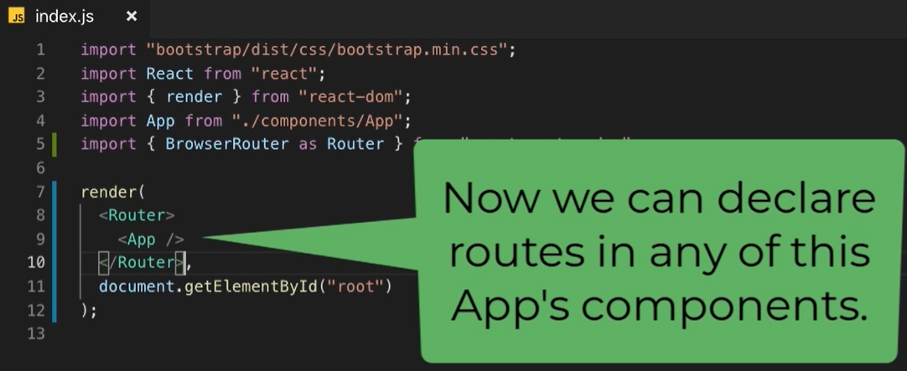

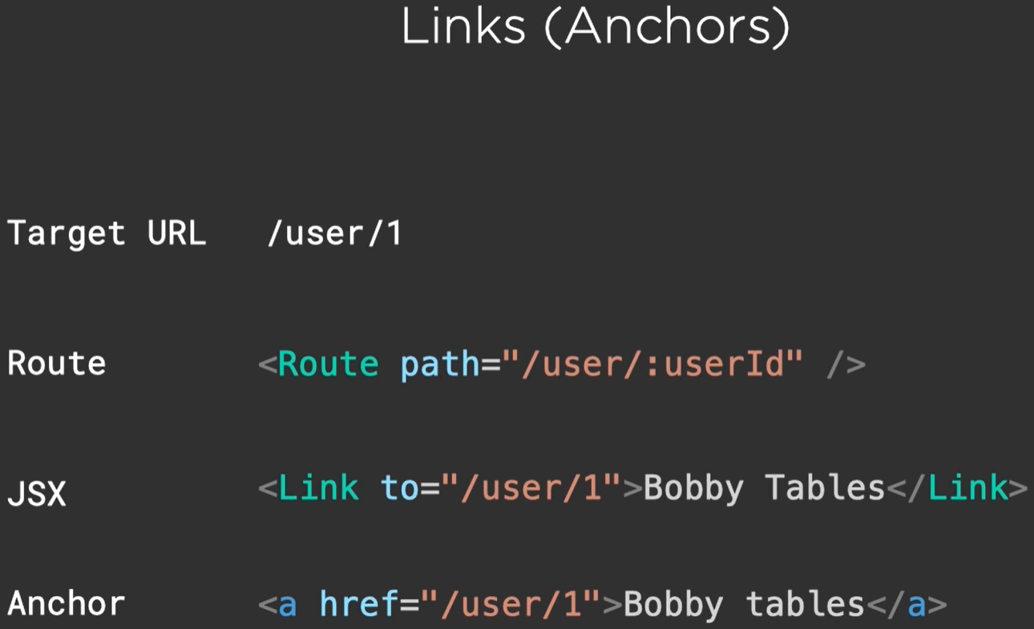 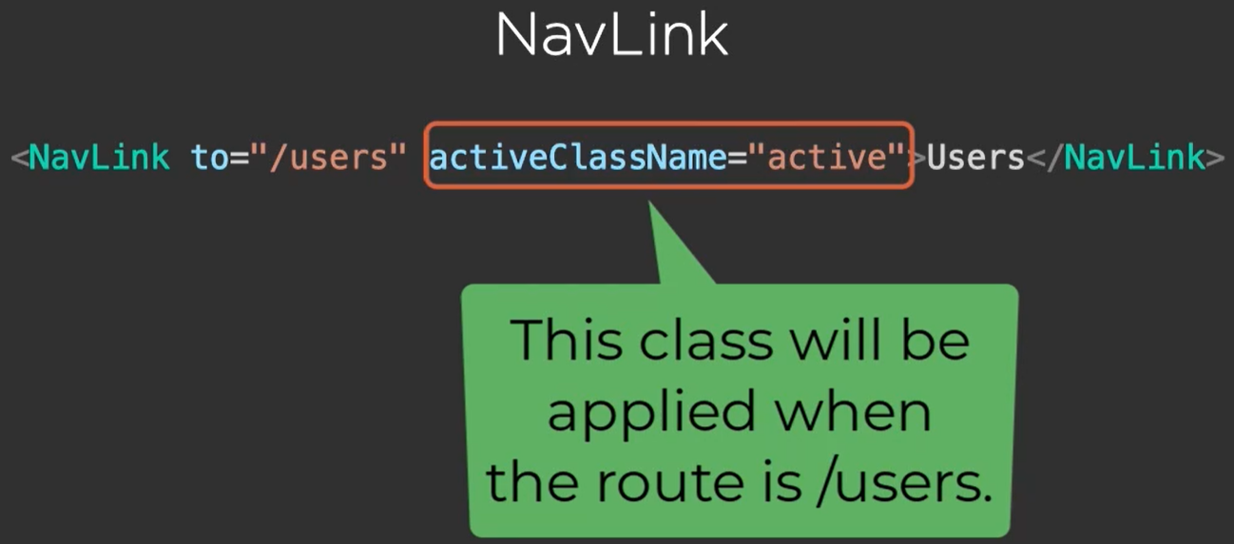

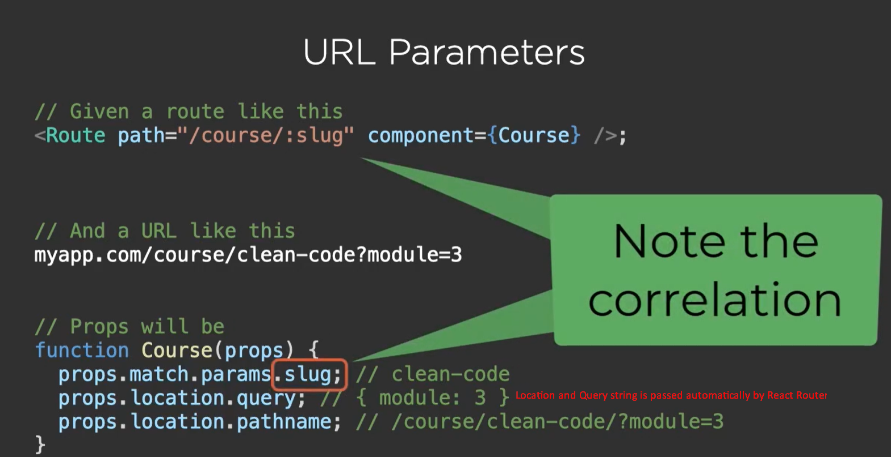

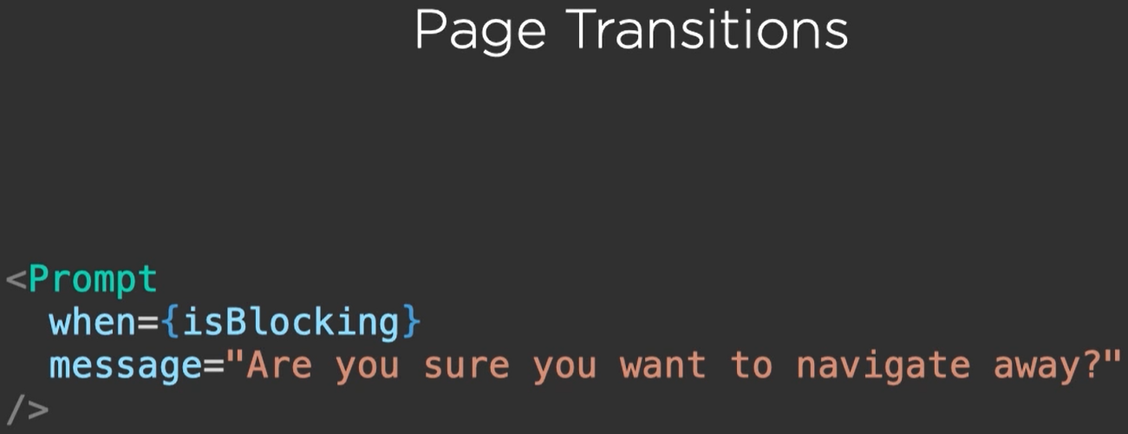

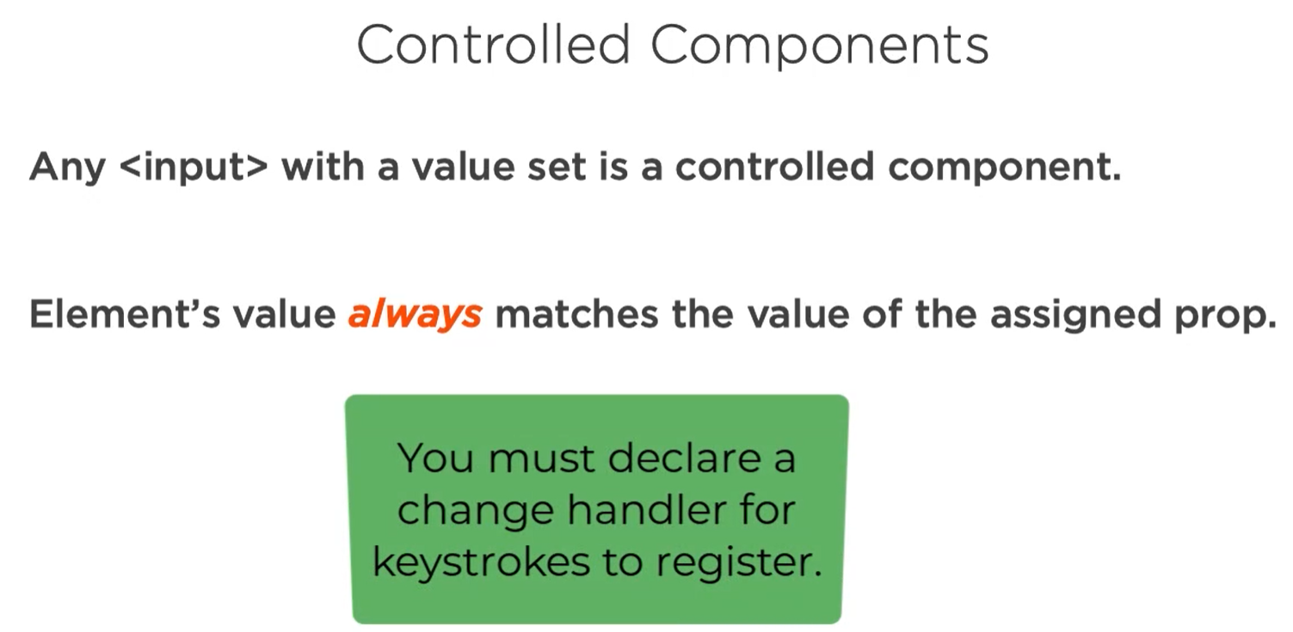

FLUX

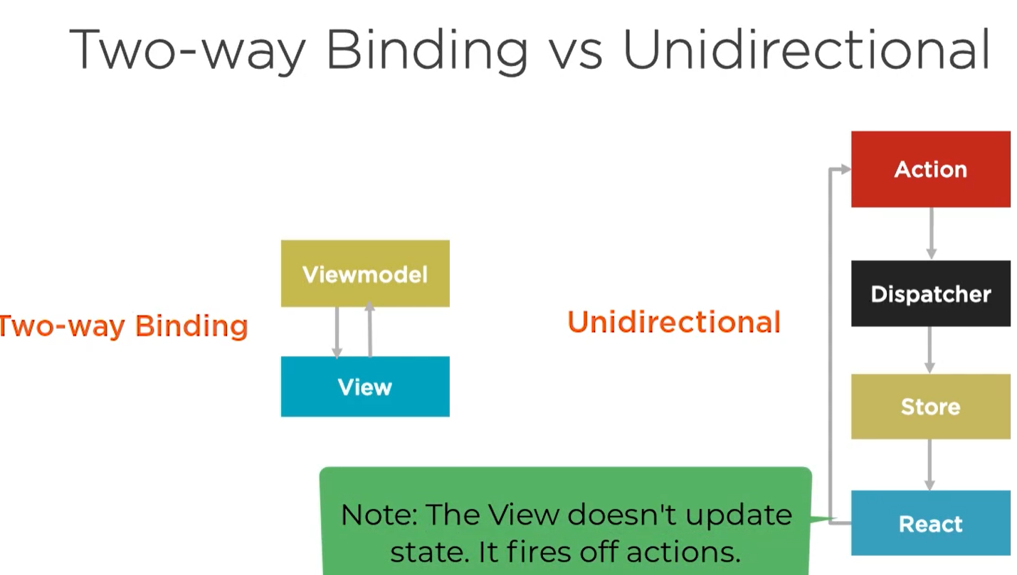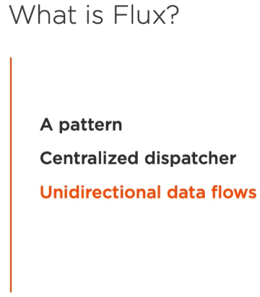

Flux is a pattern for managing how data flows through a React application. As we've seen, the preferred method of working with React components is through passing data from one parent component to it's children components. The Flux pattern makes this model the default method for handling data.

There are three distinct roles for dealing with data in the flux methodology:

* Dispatcher
* Stores
* Views (our components)

The major idea behind Flux is that there is a single-source of truth (the stores) and they can only be updated by triggering *actions*. The actions are responsible for calling the dispatcher, which the stores can *subscribe* for changes and update their own data accordingly.

When a dispatch has been triggered, and the store updates, it will emit a change event which the views can rerender accordingly.

This may seem unnecessarily complex, but the structure makes it incredibly easy to reason about where our data is coming from, what causes its changes, how it changes, and lets us track specific user flows, etc.

The key idea behind *Flux* is:

Data flows in one direction and kept entirely in the stores.

